CAMS Alarm Explorer — User Manual
Oct 31, 2026 · @Badr

Introduction
CAMS Alarm Explorer turns a CAMS for HIS alarm export from Yokogawa CENTUM VP into a searchable alarm list and a statistics dashboard, in five minutes and with no installation. It is for operations, control and alarm-management engineers who need to review alarm priorities, setpoints and enabled/disabled status across a whole plant.
From one exported sheet the app shows, for every alarm:
- Tag and Alarm Type, split from the Source column (200PIT356.OOP → tag 200PIT356, type OOP)
- Priority: the current priority, from Alarm Priority - modified
- Mark Color: the current tag mark colour, from Tag Mark Color - modified
- Detection: whether the alarm is Enabled or Disabled
- Setpoint: the current setpoint, from Alarm Setpoint - master
- Rationalization fields whenever they hold data: Purpose, Consequence, Time-to-respond, Guidance, Cause.Of.Alarm, Consequence.If.Alarm.Is.Missed, Purpose.Of.Alarm, Highly.Managed.Alarm and Alarm.Class
- Any other attribute in the export, through the Columns chooser
Your data stays on your PC. The sheet is read inside your browser and is never uploaded, even when you use the online (Vercel) version.
Developed by Mohamed Badr · Portfolio · LinkedIn

Step 1 — Export the alarms from CAMS for HIS
Export the alarm list from CAMS for HIS Alarm Builder as a CSV with file headers; the app needs nothing else. Without headers the file has no column names, and the app cannot tell which column is which.
- On the HIS or engineering station, open CAMS for HIS Alarm Builder
- In the Overview tree, select the scope to export: CENTUM for the whole plant.
- Open the Export dialog from the File menu.
- Keep every row in the Export column ticked. At minimum the app needs Source, Alarm Priority - modified, Tag Mark Color - modified, Detection and Alarm Setpoint - master.
- Under Export Option, tick Export with File Headers.
- Click Export…, choose a folder and file name, and save the CSV.
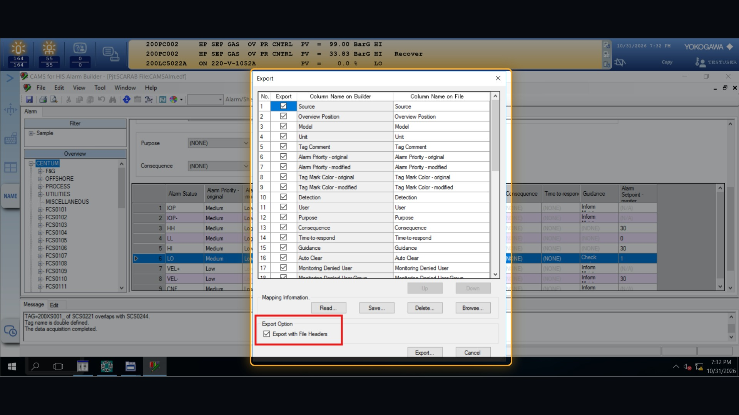
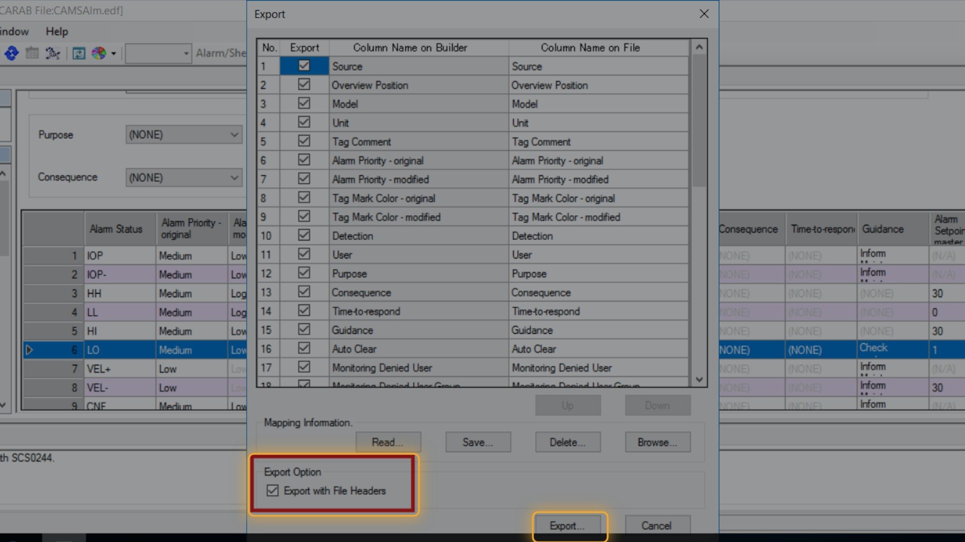
Good to know:
- The exported file starts with four information lines (@PRODUCTS, @ID, @SHEET, @DATA) before the column headers. The app skips them and shows the @DATA export date in its top bar.
- You can open the CSV in Excel and save it as .xlsx; the app reads that too, as long as the header row is kept.
- Size is not a problem: a full plant export of 80,846 alarms (42 MB) loads in about 2–3 seconds.

Step 2 — Open the app and import the file
Open the app, then drop the exported file on it; nothing needs installing.
- Open the app in Chrome or Edge, either way:
  - Online: open your Vercel link (for example https://cams-alarm-explorer.vercel.app).
- Drag the exported file onto the page, or click Choose file… (later: Import sheet in the top bar).
- Wait for Loaded N alarms. The top bar then shows the file name, alarm and tag counts, and the export date.
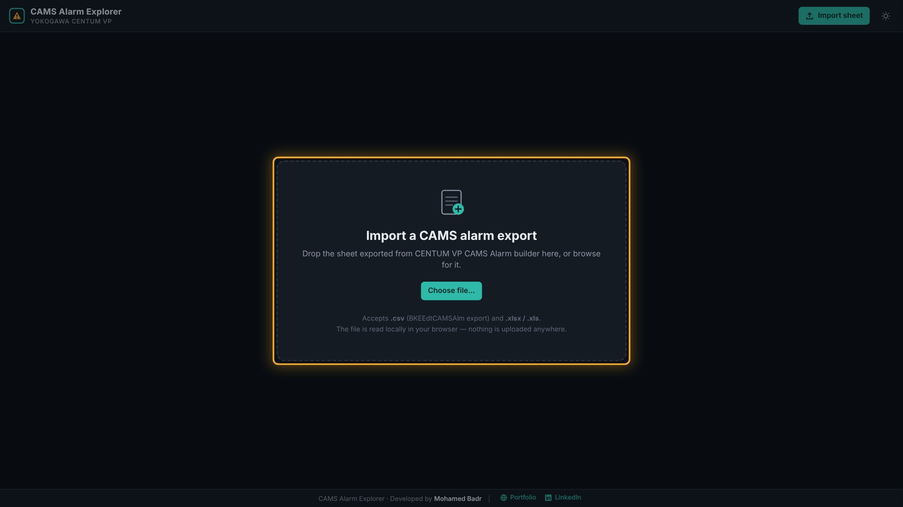
Accepted file | Notes
.csv | The CAMS export as saved; Windows (ANSI) and UTF-8 encodings both work
.xlsx, .xls | The same sheet saved from Excel; the app finds the sheet with the Source column
The app keeps the last imported sheet in this browser. When you open the app again it reloads that sheet automatically, and the top bar shows saved in this browser.
To import a newer export, click Remove import in the top bar and confirm; the app returns to the start screen, ready for the new sheet. Clicking Import sheet also works: the new sheet replaces the saved one. Removing an import only clears the browser copy; the file on your PC is not affected.
The saved copy stays in this browser on this PC only. On a shared PC, use Remove import when you finish if others should not see the data.

Step 3 — Review alarms in the Alarms tab
The Alarms tab lists one row per alarm, with summary tiles on top and filters above the table.
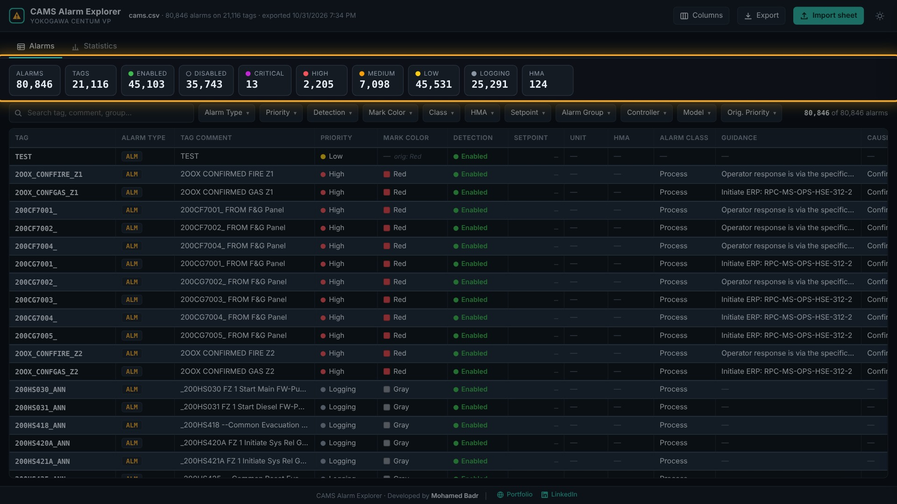
Summary tiles count the alarms in the current view: alarms, tags, enabled, disabled, each priority and HMA. Click a tile to filter by it; click it again to clear.
Default columns
Column | Source in the export | What it shows
Tag | Source, before the last dot | 200PIT356
Alarm Type | Source, after the last dot | OOP, HH, IOP…
Tag Comment | Tag Comment | Tag description
Priority | Alarm Priority - modified | Current priority, with a coloured dot
Mark Color | Tag Mark Color - modified | Current mark colour; if blank, the original is shown in grey as orig: Red
Detection | Detection | Enabled or Disabled
Setpoint | Alarm Setpoint - master | Current setpoint (— for alarms without one)
Unit | Unit | Engineering unit
HMA | Highly.Managed.Alarm | HMA badge for highly managed alarms
Alarm Class | Alarm.Class | Process or Diagnostic
Purpose, Consequence, Time-to-respond, Guidance, Cause of Alarm, Consequence if Missed, Purpose of Alarm | Same names | Shown whenever the export holds data for them
Columns that are empty ((NONE)) for every alarm in the file are hidden automatically; you can still turn them on in Columns.

Search and tag grouping
Type in the search box to match tag, source, comment, alarm group or model; several words must all match. Press / to jump to the search box.
Rows of the same tag share one background shade, and the shade switches at each new tag. A divider marks where a new tag starts, and the tag name is bold on its first row.
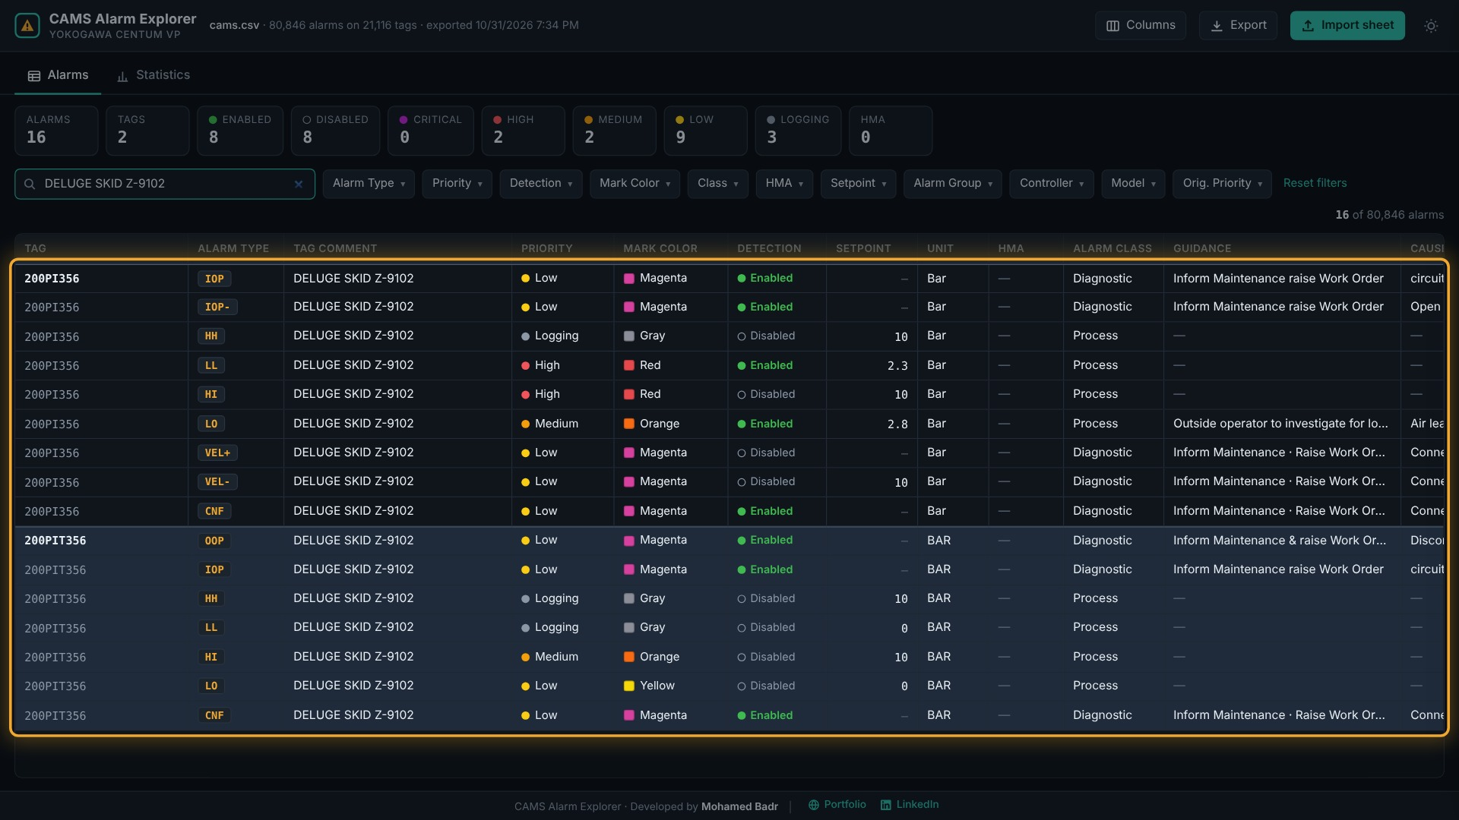

Filters and sorting
Use the filter buttons (Alarm Type, Priority, Detection, Mark Color, Class, HMA, Setpoint, Alarm Group, Controller, Model, Orig. Priority). Each lists its values with counts; tick one or more. A number on the button shows how many values are selected. Reset filters clears all.
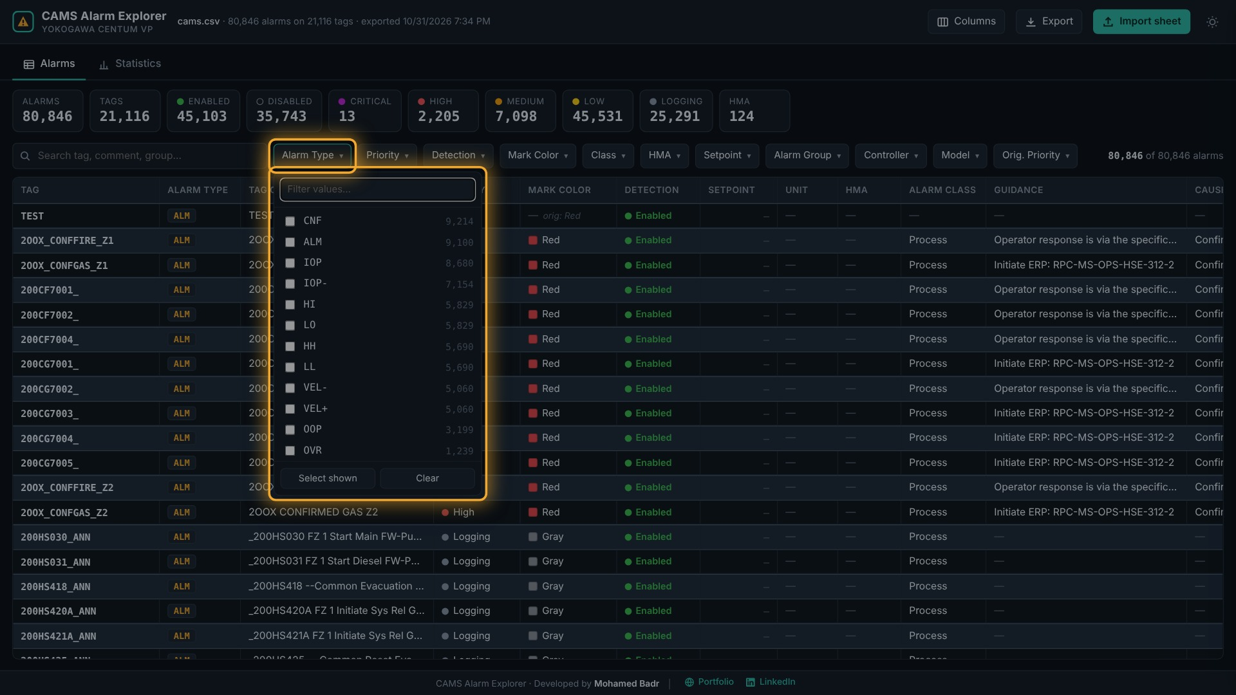
Click a column header to sort ascending, again for descending, a third time to clear. Drag a header's right edge to resize it; widths are remembered.

Tag details
Click any row to open the details panel. It lists every alarm on that tag with priority, colour, detection and setpoint, followed by all attributes of the selected alarm. Click another alarm in the list to switch to it; Show empty reveals blank attributes; Esc closes the panel.
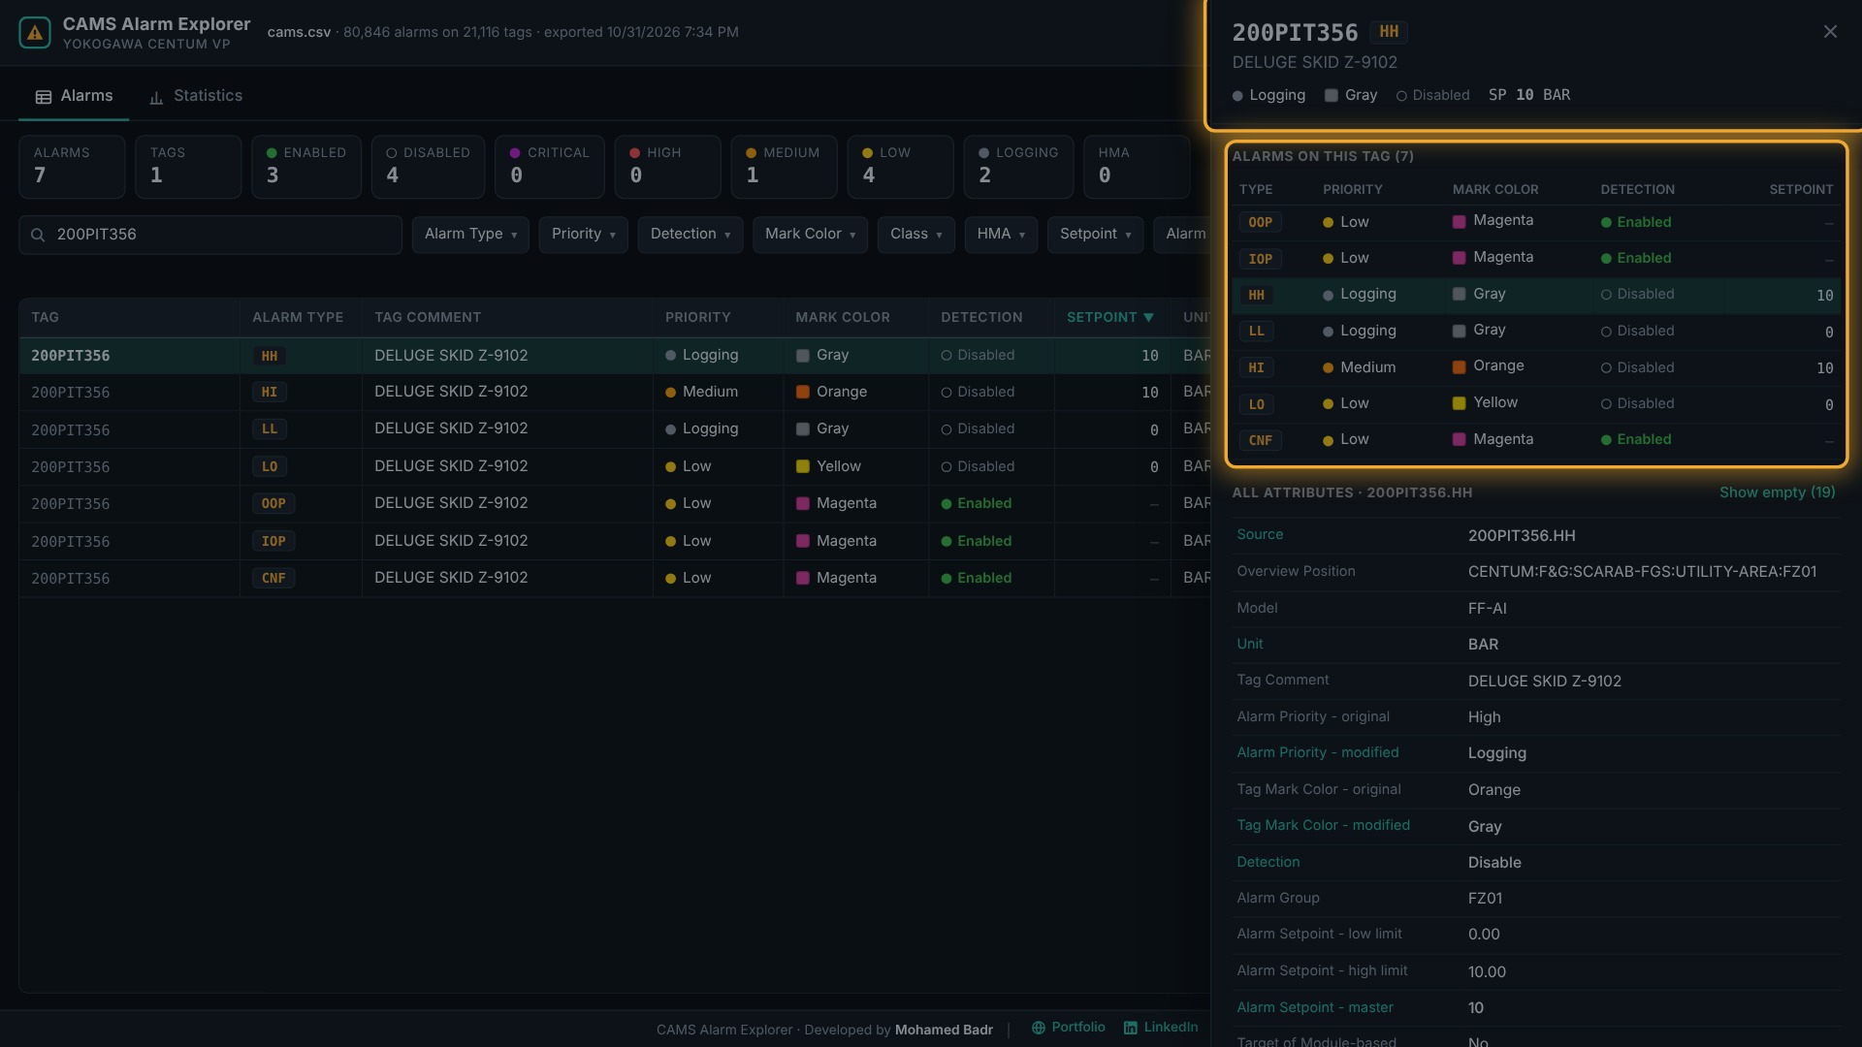

Showing all attributes
Click Columns to show or hide any of the export's attributes. All shows every column, All with data skips empty ones, and Default returns to the standard view. Your choice is remembered for next time.
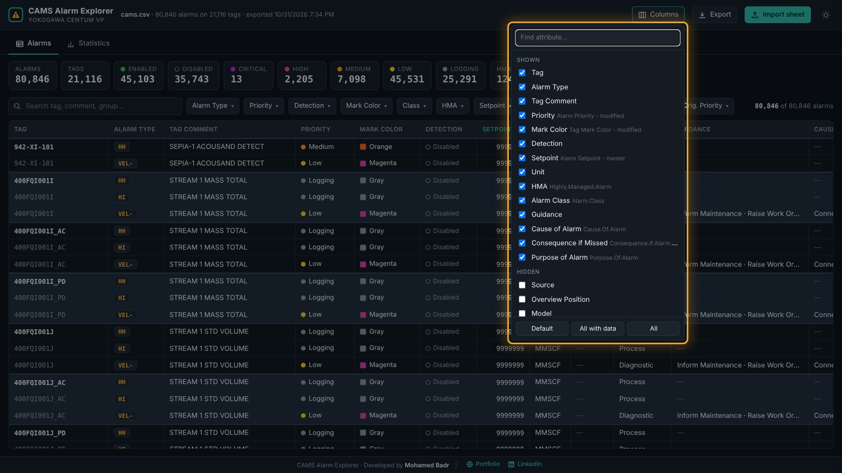

Step 4 — Analyse with the Statistics tab
The Statistics tab summarises the alarms that match your current search and filters, so filtering to one area or controller gives that area's statistics. Hover any bar for its exact count; click it to open those alarms in the Alarms tab.
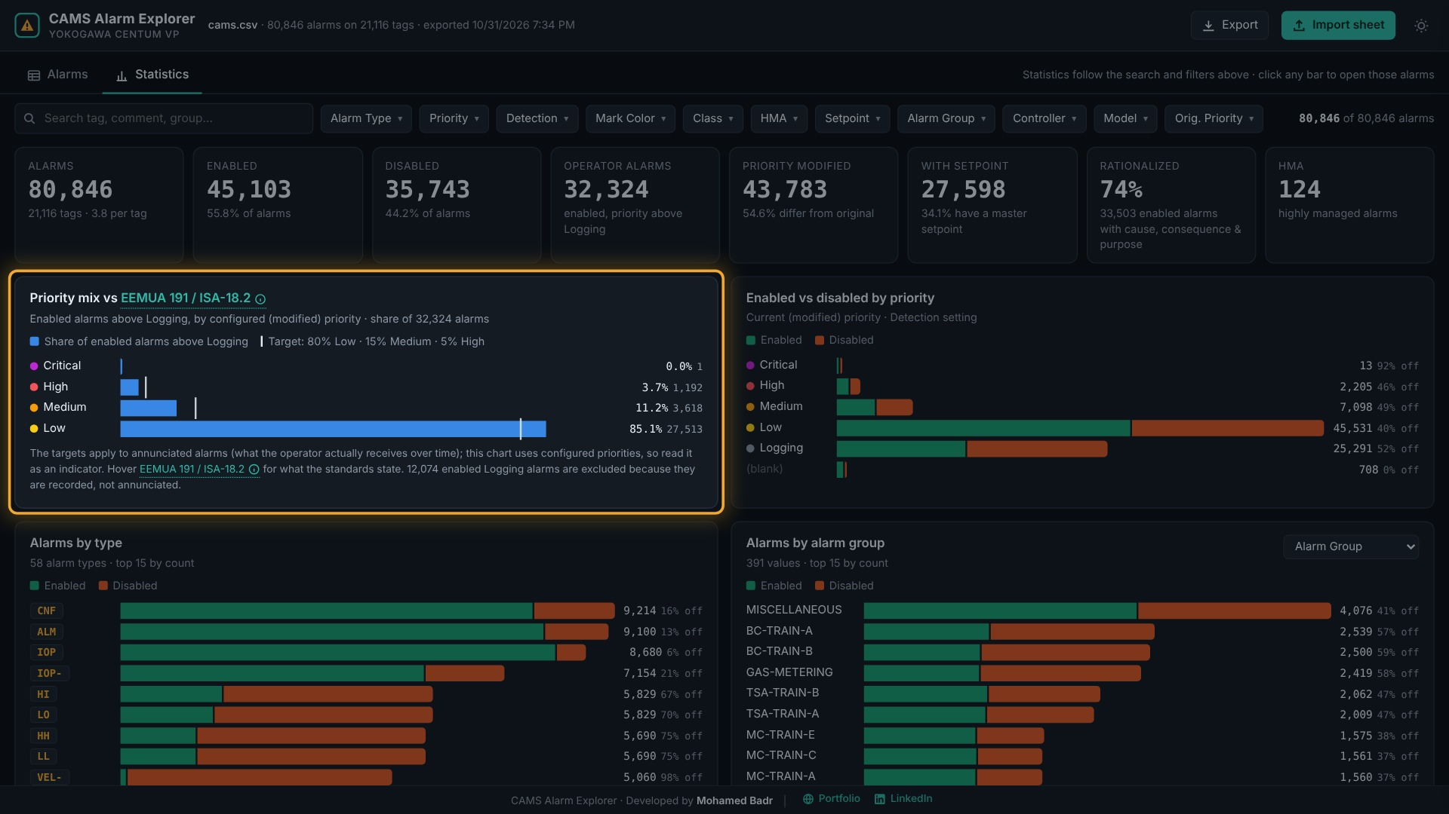
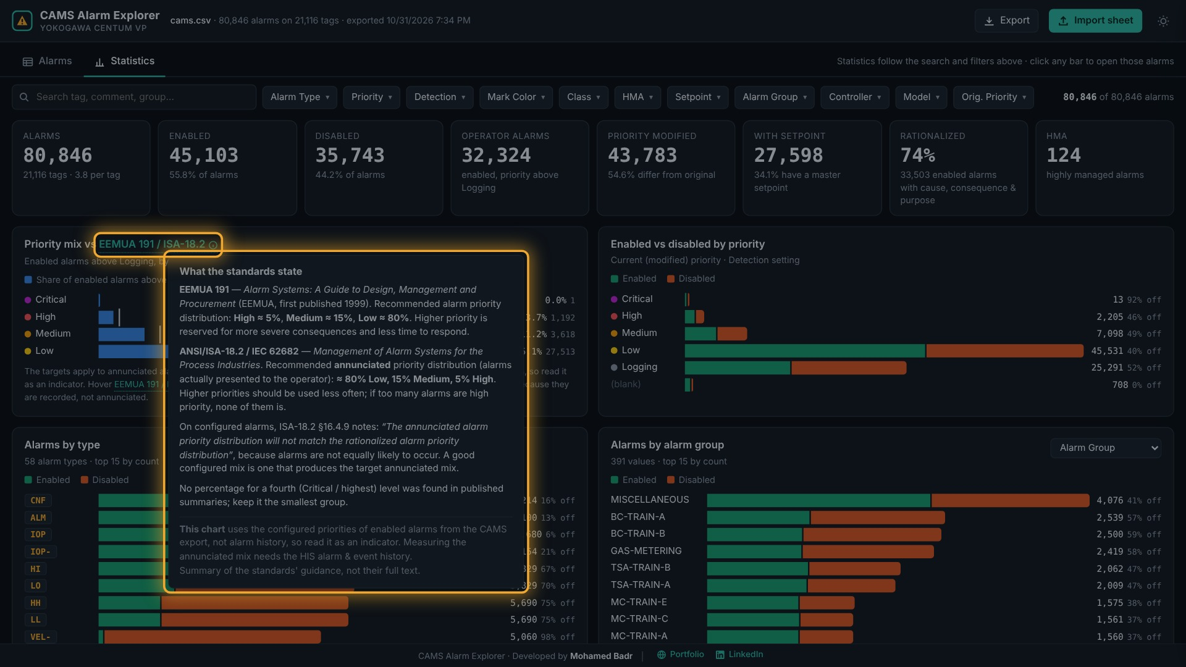
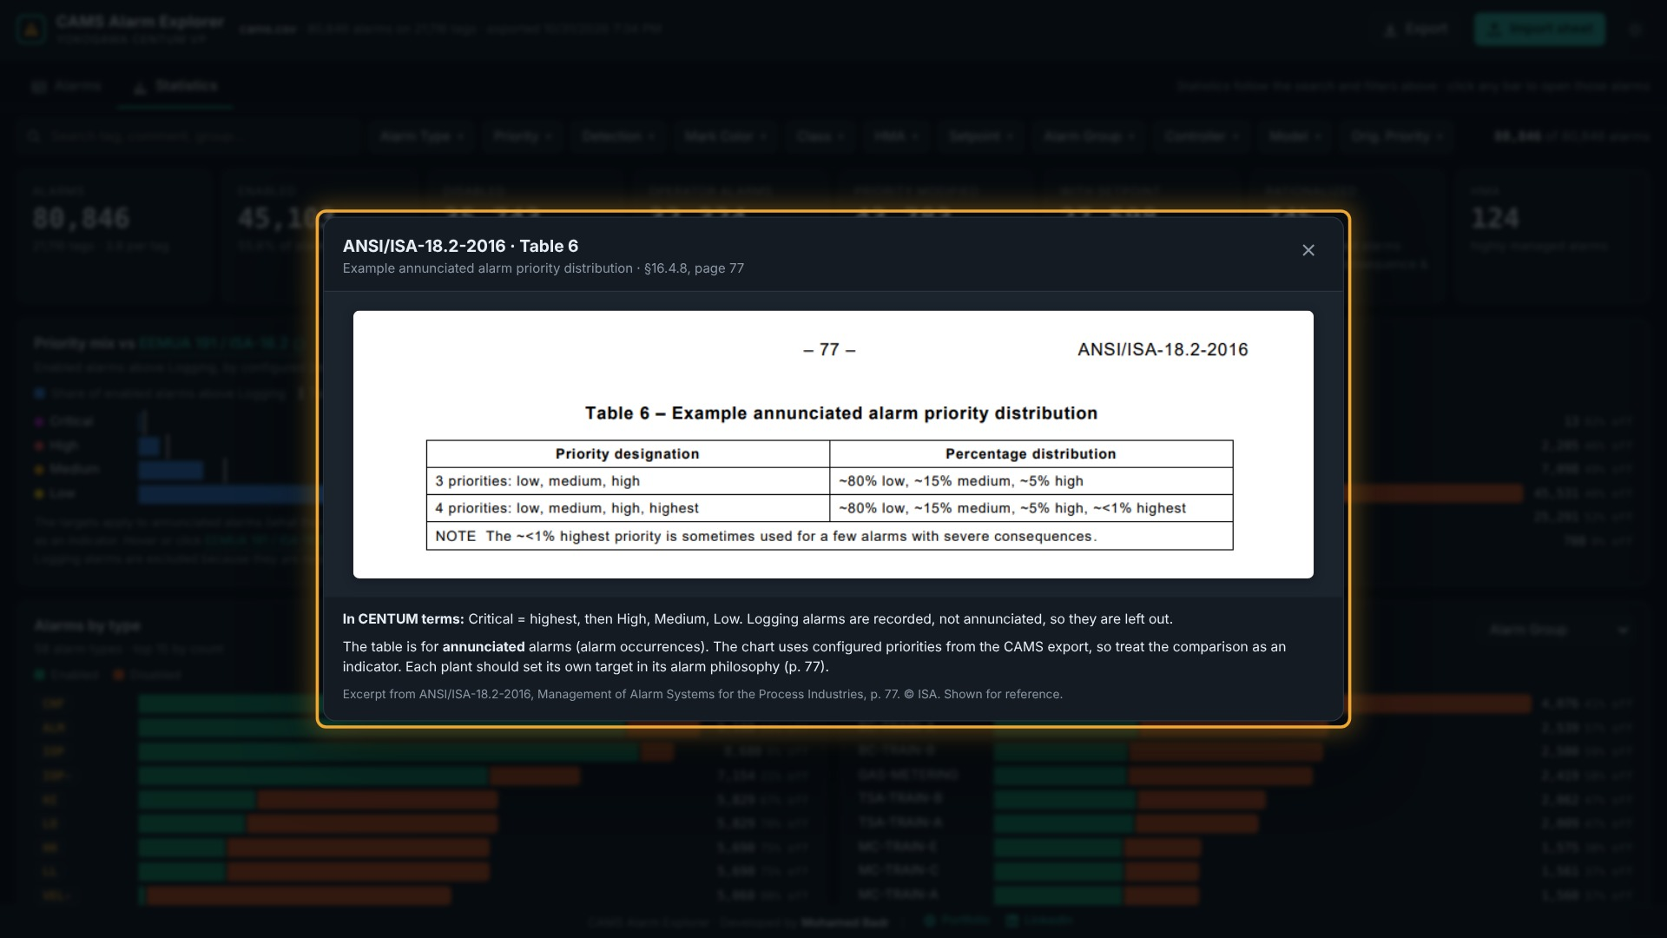
Chart | What it tells you
Headline tiles | Alarms, tags, enabled, disabled, operator alarms (enabled, above Logging), priority modified, with setpoint, rationalized, HMA. Some tiles are clickable filters.
Priority mix vs EEMUA 191 / ISA-18.2 | Share of enabled alarms above Logging per configured priority, against the targets in ANSI/ISA-18.2-2016 Table 6 (p. 77): ~80% Low, ~15% Medium, ~5% High, ~<1% Critical (highest). Hover the standard's name for what ISA-18.2 and EEMUA 191 state, with page references; click View ISA-18.2 Table 6 to see the table itself. The targets apply to annunciated alarms (what operators receive over time), so with configured priorities this is an indicator (§16.4.9, p. 77). Logging alarms are excluded because they are recorded, not annunciated.
Enabled vs disabled by priority | How many alarms of each current priority are enabled or disabled
Alarms by type | The 15 most common alarm types, split enabled / disabled; the rest are counted in a note
Alarms by alarm group / controller / model | Pick the breakdown in the dropdown; top 15 shown
Priority changes, original → modified | A matrix of how priorities were re-assigned; outlined cells are unchanged
Tag mark colour | Alarms per current mark colour, enabled / disabled
Rationalization completeness | Share of enabled alarms with cause, consequence, purpose, guidance, response time and other fields filled in
Alarm class | Process vs Diagnostic, enabled / disabled
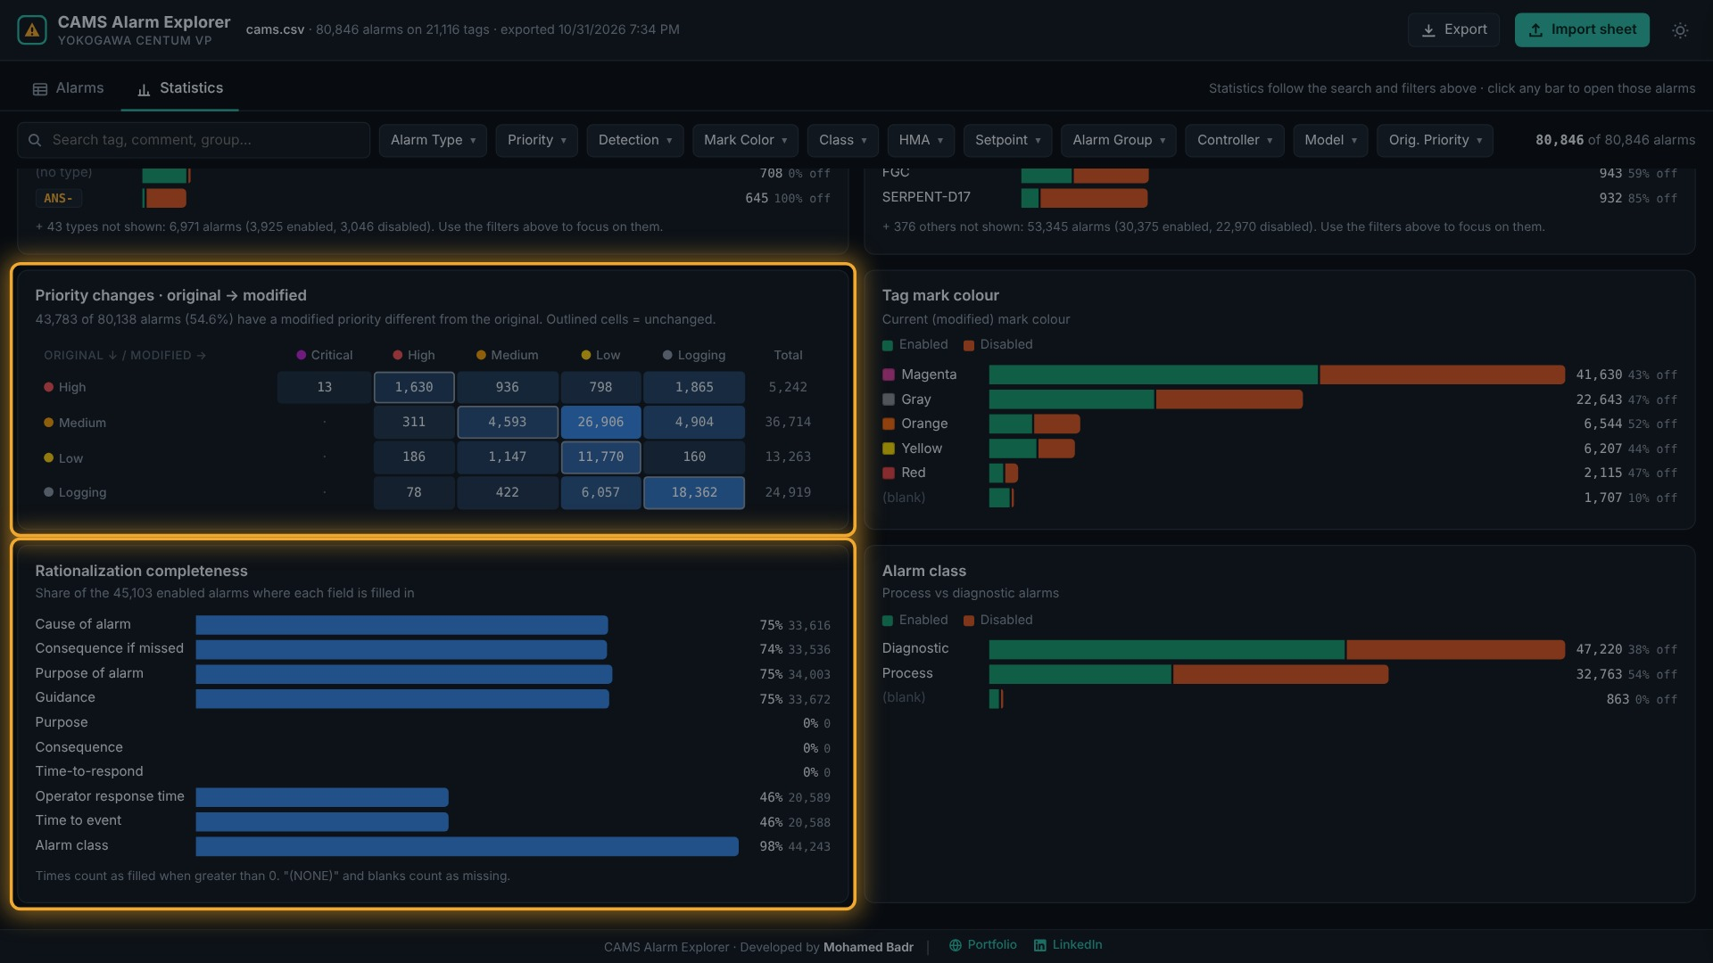
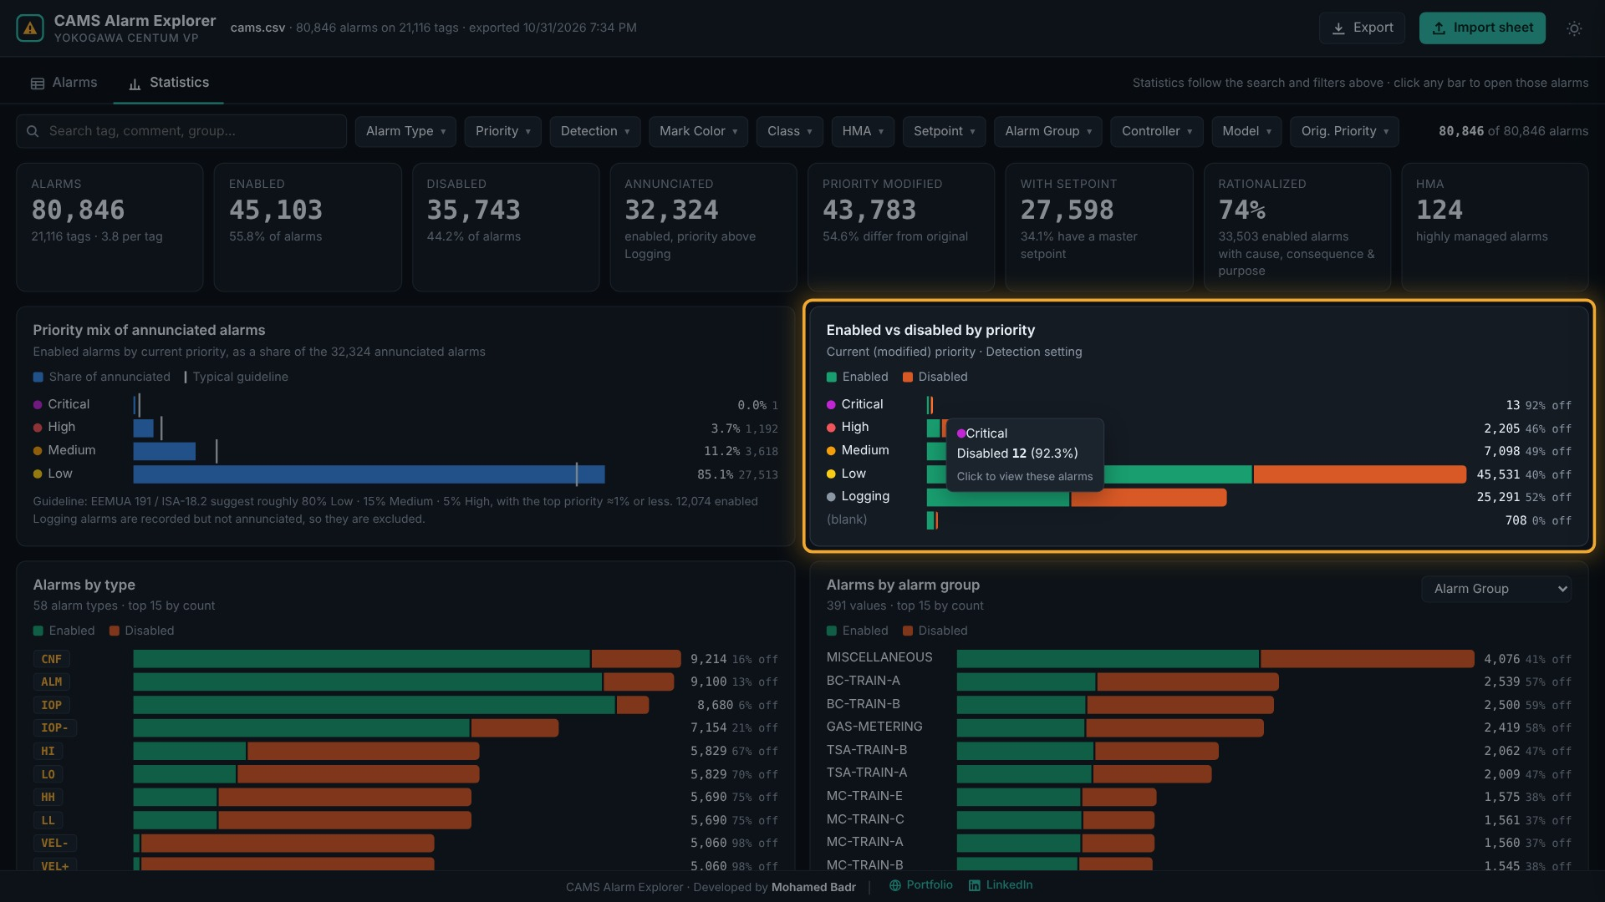
Example: clicking the orange Disabled part of the Critical bar opens exactly the disabled Critical alarms in the Alarms tab, with the Priority and Detection filters set. Use Reset filters to go back.

Highly managed alarms (HMA)
Click Highly managed alarms at the top of the Statistics tab to switch to the HMA view. It covers the alarms whose Highly.Managed.Alarm field is HMA, and follows the same search and filters as the rest of the app. Overview switches back.
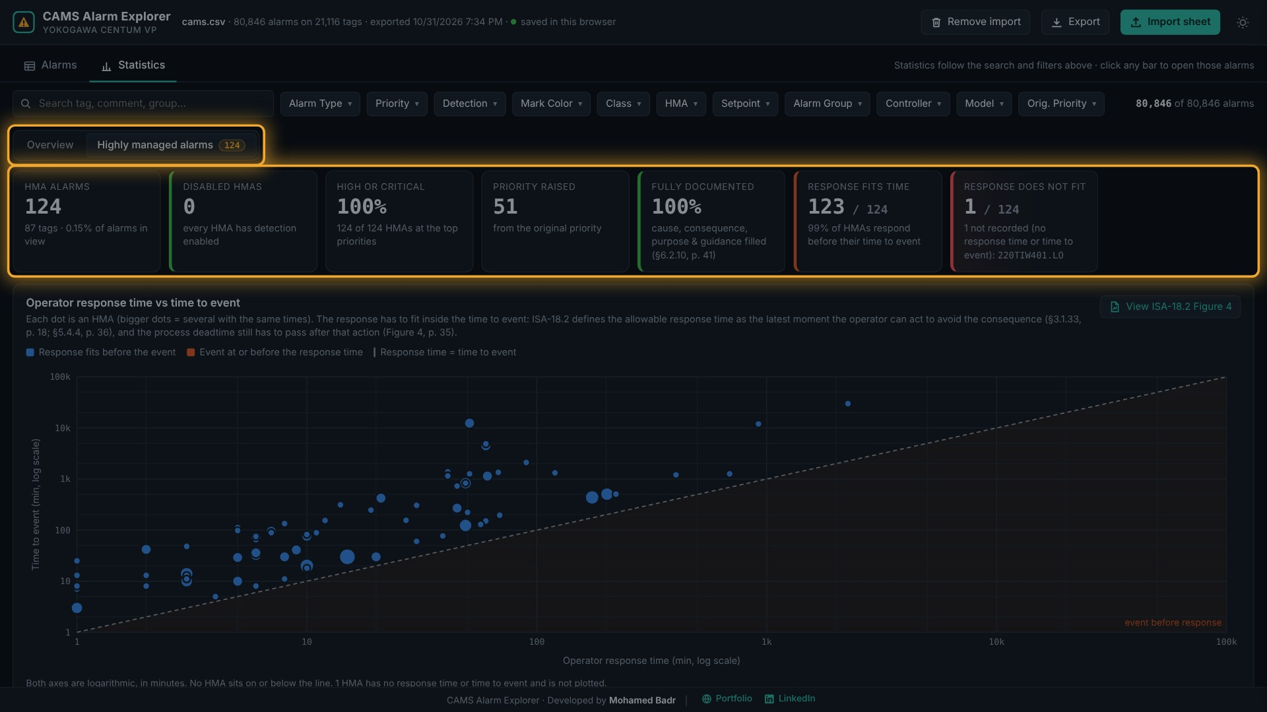
Chart | What it tells you
HMA tiles | HMA count and tags; disabled HMAs (an out-of-service HMA needs interim alarms or procedures, ISA-18.2 §15.3.3, p. 73); share at High or Critical; how many were raised from their original priority; fully documented, meaning cause, consequence, purpose and guidance are filled (§6.2.10, p. 41); Response fits time, the HMAs out of all HMAs that respond before their time to event (click it to open Figure 4 from the standard); and Response does not fit, the HMAs that are too late (event at or before the response time) or have no response time or time to event recorded, with their names. Click that card to list only those HMAs in the HMA register; Show all returns the full list.
Operator response time vs time to event | One dot per HMA, both axes on log scales in minutes. Below the dashed line the consequence would arrive before the operator's response time. ISA-18.2 defines the allowable response time as the latest moment the operator can act to avoid the consequence (§3.1.33, p. 18; §5.4.4, p. 36). Click View ISA-18.2 Figure 4 to see the alarm response timeline (Figure 4, p. 35) and §5.4.6 (p. 36): the process deadtime still has to pass after the operator acts, and the export has no deadtime field, so check small margins against the process. Hover a dot for its tags and margin; click a single dot to open that alarm.
HMA priority: original → current | How the priority of each HMA was changed from the original value. ISA-18.2 allows HMA classes to be considered when setting priority (§9.5, p. 49).
HMAs by alarm type; by controller, alarm group or model | Enabled and disabled HMAs per alarm type and per area; pick the area breakdown in the dropdown.
HMA documentation | Share of HMAs with cause, consequence, purpose, guidance, operator response time, time to event and setpoint filled in.
HMA register | Every HMA with its priority change, detection, setpoint, response time, time to event and margin (time to event minus response time), tightest margin first. Click a row to open the alarm in the Alarms tab.
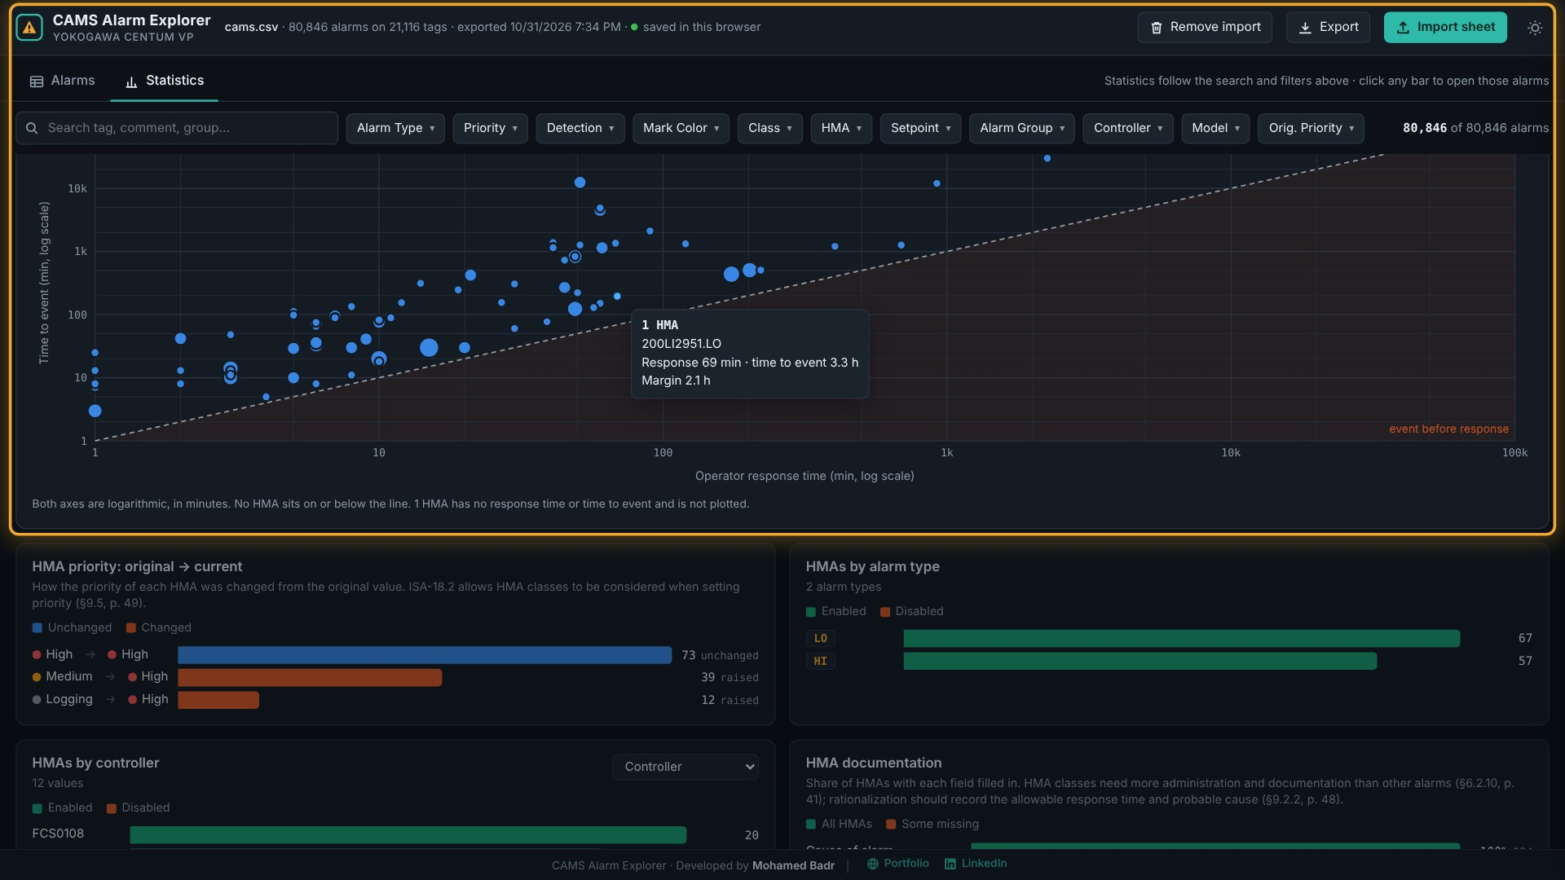
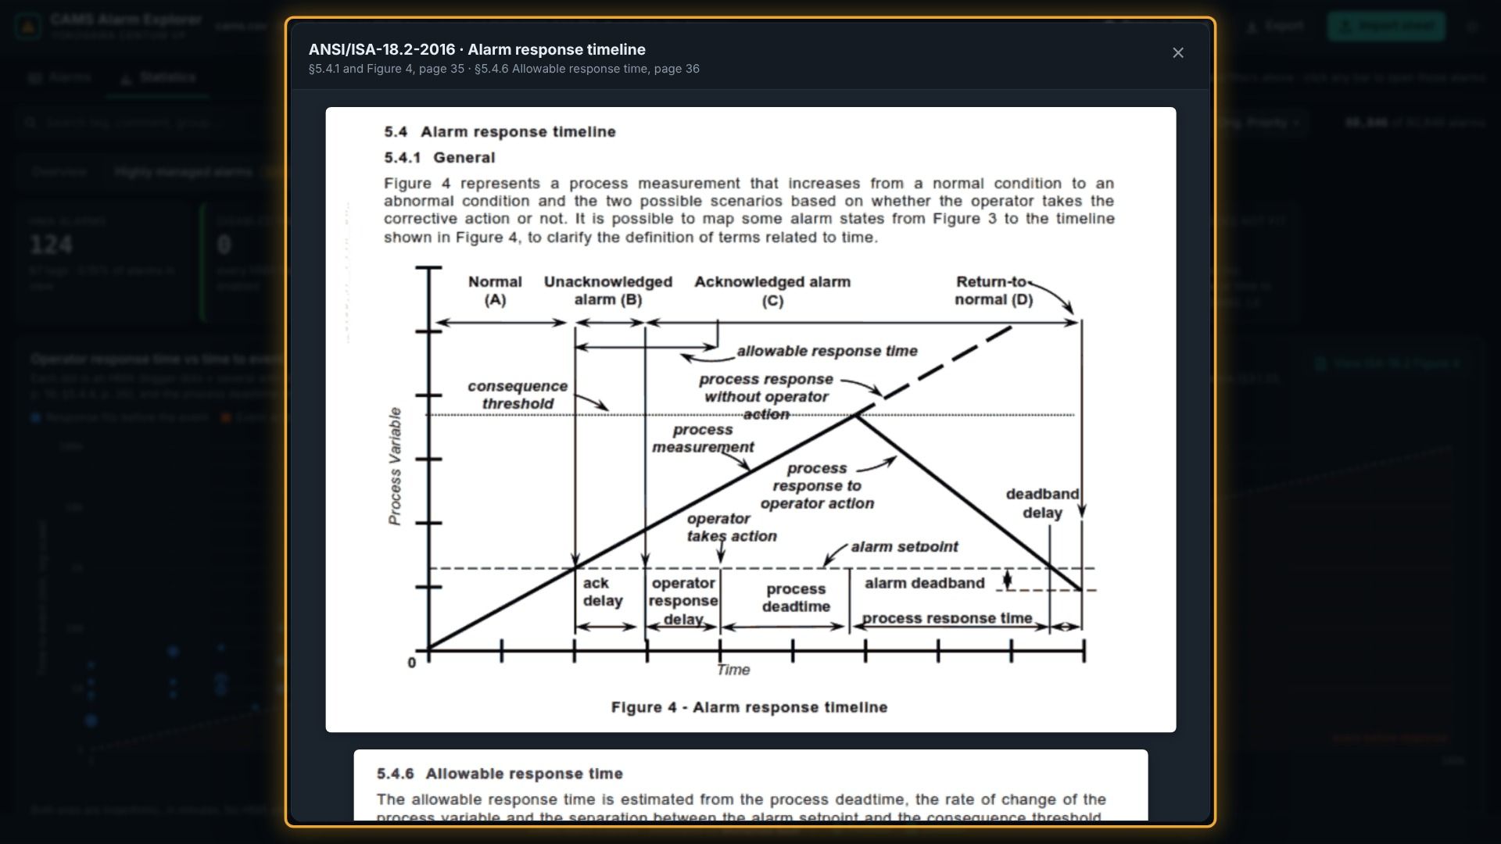
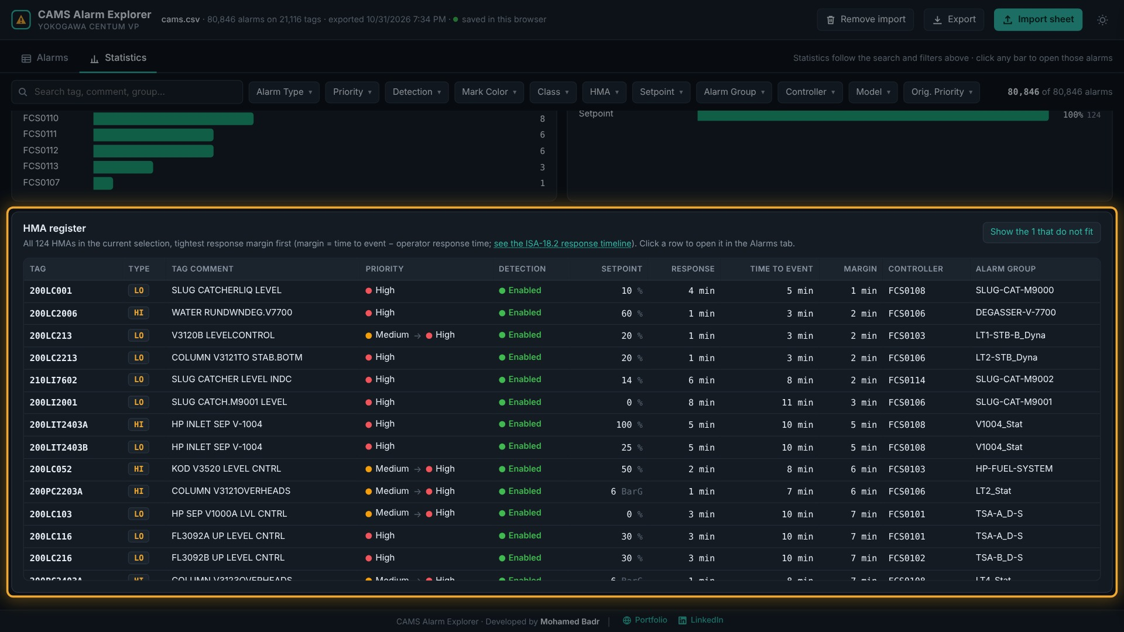
In the 31 Oct 2026 export: 124 HMAs on 87 tags, all enabled, all at High priority and fully documented; 51 were raised from Medium or Logging. 123 of the 124 respond before their event; the tightest is 200LC001 LO, with a 1-minute margin (4 min response, 5 min to event). 220TIW401.LO (TO SC 220-M-9000, FCS0108) has no response time or time to event recorded, so it cannot be checked.

Step 5 — Export the results
Click Export in the top bar to take the current, filtered list out of the app.
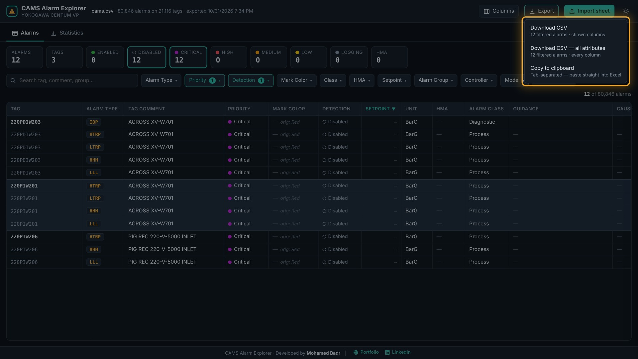
Option | What you get
Download CSV | The filtered alarms with the columns currently shown, as <file>_filtered.csv
Download CSV — all attributes | The filtered alarms with every column of the export, plus Tag and Alarm Type
Copy to clipboard | The filtered alarms and shown columns, tab-separated; paste straight into Excel

